
Waleed Afzal
23P-0566
CN – LAB 08
Section 5C
Date: 10/10/25

Lab Tasks:

Question 1:
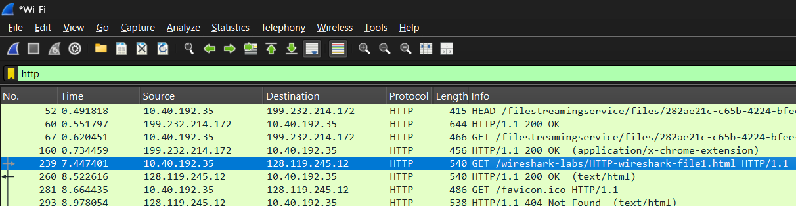
Get Method:
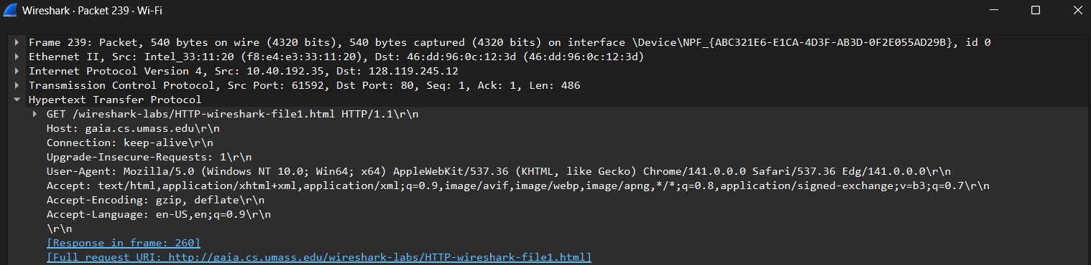
Response Message:
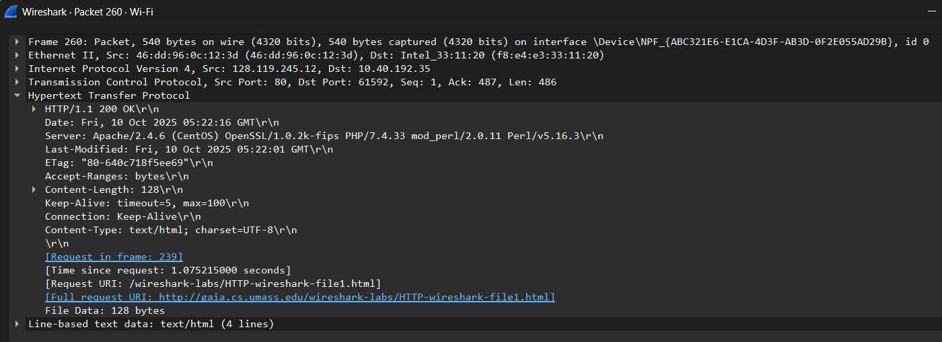
Q1: Is your browser running HTTP version 1.0 or 1.1? What version of HTTP is the server running?
Ans: The browser is running HTTP 1.1 version
Q2: What languages (if any) does your browser indicate that it can accept to the server?
Ans: EN-US, en
Q3: What is the IP address of your computer? Of the gaia.cs.umass.edu server?
Q4: What is the status code returned from the server to your browser?
Ans: Status Code is 200 OK
Q5: When was the HTML file that you are retrieving last modified at the server?
Q6: How many bytes of content are being returned to your browser?
Q7: By inspecting the raw data in the packet content window, do you see any headers within the data that are not displayed in the packet-listing window? If so, name one.
The Cookie and Authorization headers are missing in the packet-listing window
Question 2:
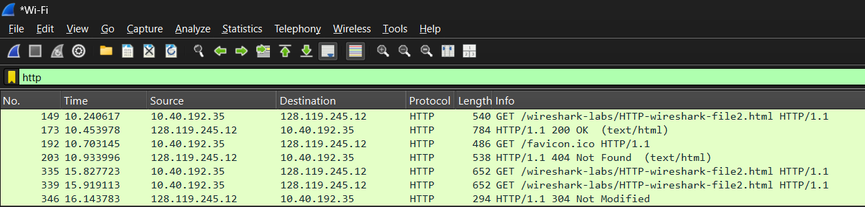
Q8: Inspect the contents of the first HTTP GET request from your browser to the server. Do you see an “IF-MODIFIED-SINCE” line in the HTTP GET?
Ans: There is no IF-MODIFIED-SINCE header in the first GET Request
Q9: Inspect the contents of the server response. Did the server explicitly return the contents of the file? How can you tell?
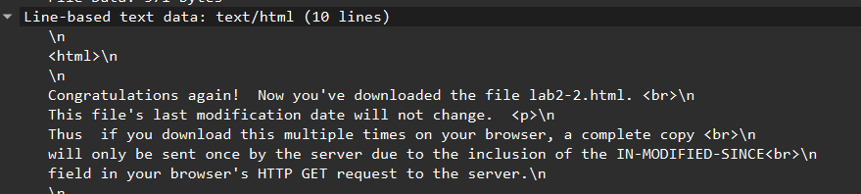
Q10: Now inspect the contents of the second HTTP GET request from your browser to the server. Do you see an “IF-MODIFIED-SINCE:” line in the HTTP GET? If so, what information follows the “IF-MODIFIED-SINCE:” header?
Q11: What is the HTTP status code and phrase returned from the server in response to this second HTTP GET? Did the server explicitly return the contents of the file? Explain.
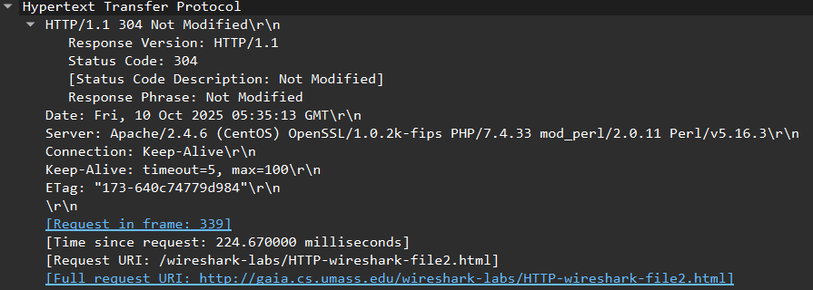It shows not modified because the content is already stored in cache so it will not send the same data again to the browser and the browser can get that particular data again from the cache.
Question 3:
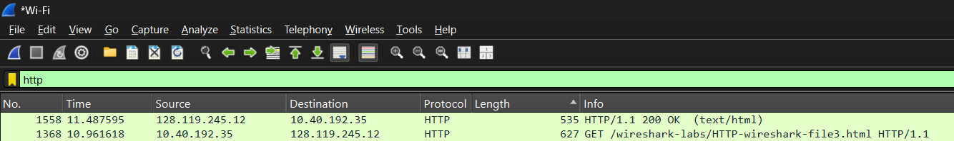
Q12: How many HTTP GET request messages did your browser send? Which packet number in the trace contains the GET message for the Bill or Rights?
1 HTTP Get request message was sent by the browser but the data is received into 3 segments
The packet number that contains the GET message is: “1368”
Q13: Which packet number in the trace contains the status code and phrase associated with the response to the HTTP GET request?
The packet number of response message is “1558”

Q14: What is the status code and phrase in the response?
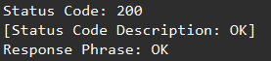
Q15: How many data-containing TCP segments were needed to carry the single HTTP response and the text of the Bill of Rights?
Three data containing segments were needed to carry the single HTTP response of 4500 bytes because that size was large enough to be received in single segment.
Question 4:
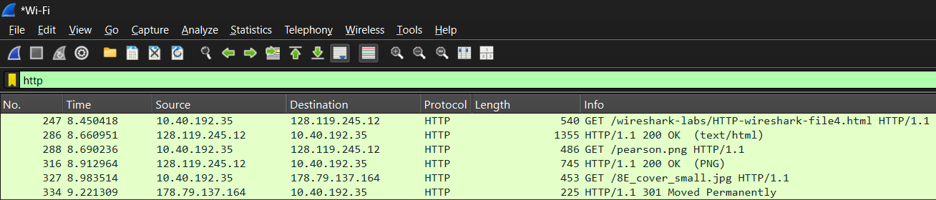
Q16: How many HTTP GET request messages did your browser send? To which Internet addresses were these GET requests sent?
Three GET Request message was sent by the browser with the Destination address respectively:
- 128.119.245.12
- 128.119.245.12
- 178.79.137.164
Q17: Can you tell whether your browser downloaded the two images serially, or whether they were downloaded from the two web sites in parallel? Explain.
Both images were downloaded parallel according to the time measurements:
LOGO PNG:
BOOK COVER JPG:

Question 5:
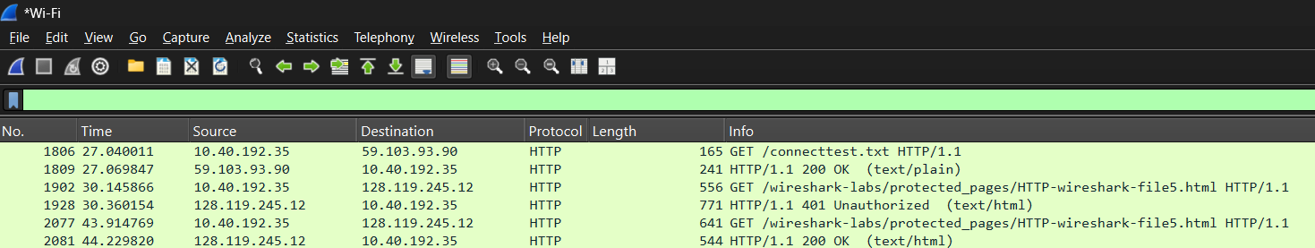
Q: What is the server’s response (status code and phrase) in response to the initial HTTP GET message from your browser?
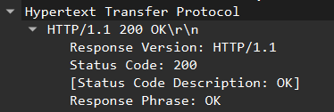
Q: When your browser sends the HTTP GET message for the second time, what new field is included in the HTTP GET message?
First Get Message Header:
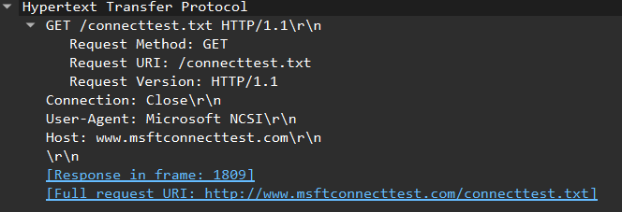
Second Get Message Header:
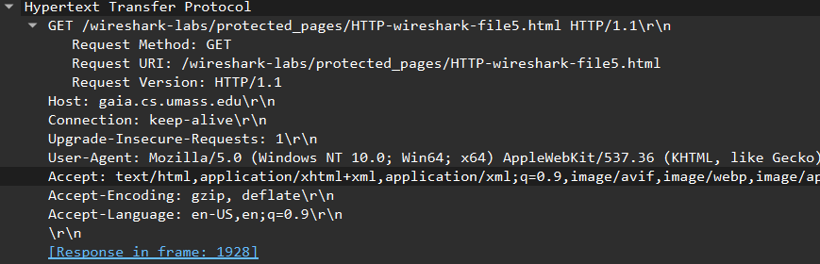
The new fields included in the second get message is as follows:
“Upgrade-Insecure-Requests”, “Accept”, “Accept-Encoding”, “Accept-Language”

